Summer Reading List for Incoming 11th Graders

Little Fires Everywhere  By Celeste Ng  Mia and Pearl move to Shaker Heights, where lives are meticulously planned and everyone falls in line. The free spirited mother daughter duo challenge this status quo while endearing themselves to the local Richardson family. When town drama pits the two families against one another old secrets are uncovered while friendships and family relationships are put at risk. | 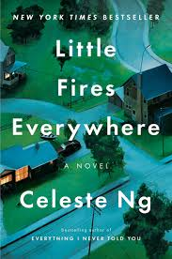
The Martian
By Andy Weir

Mark Watney is an American astronaut trapped on Mars in the year 2035. Left behind after being assumed dead he must use his knowledge of botany and superior problem solving skills to stay alive while NASA figures out how to bring him back home.
Black Enough  Edited by Ibi Zoboi  A collection of short stories that explore the issues associated with being a black teen in the United States today. Topics include family dynamics, mental health struggles, falling in love, finding yourself, and more. | 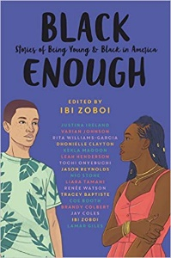
The Queen of the Tearling  By Erika Johansen  Princess Kelsea Raleigh Glynn is on a mission to overthrow the Red Queen and take back the throne that once belonged to her late mother. With the help of brave knights and a magical gemstone, Princess Kelsea fights to overcome her insecurities and discover within herself greater bravery than she’d ever imagined. | 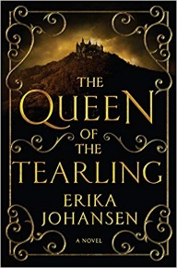

Dear Bishop Ludden Parents and Students,
This year the English Department has decided to compile a list of books for each grade. Your student will be responsible for choosing one book from their grade level list and reading it over their summer break.
Along with this, they will be responsible for taking some short notes on each chapter. These chapter notes will be collected and taken for a grade on the first day school, September 4th 2019. The function of taking these notes is two-fold. First, it is to help students break down what they are reading for better comprehension and personal analysis. Secondly, it is to show their teachers that they thoroughly read the book. Each student will receive a Chapter Chart with this list and additional copies can be printed off of the Bishop Ludden website.
In regards to obtaining a book, you can either purchase the book your student selects at any bookstore that has it available, or go to a public library and check the book out. Students will not be required to have the book for school.
As an English Department, above all else, we want this summer reading to be enjoyable. Please help your student pick a book from their grade level list that will help them not only develop a love of reading, but also interest them on a personal level.
If you have any questions you, or your student, can contact their current English teacher or Mike Morgan.
Thank you, and happy reading.
The Bishop Ludden English Department

