York  By Laura Ruby  A centuries old mystery, a determined real estate developer, and a ticking clock. This is what Tess, Theo, and Jaime are up against as they race through an alternate version of  New York City to save their homes from destruction. | 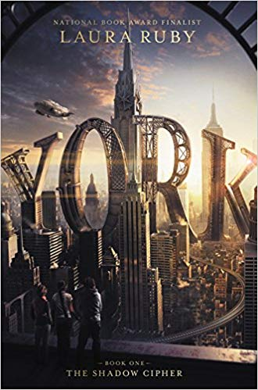
The Other F-Word  By Natasha Friend  This book is all about your average American family: four moms, four half-siblings, and one unidentified sperm donor. When medical questions cause Milo to search for the donor connections are made, feelings are hurt, and the word “family” is defined. | 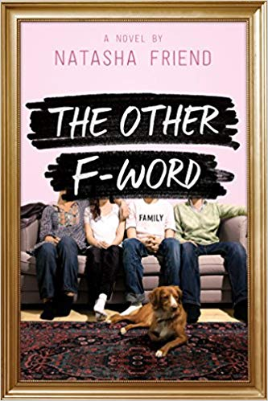
Americanized: Rebel Without a Green Card
By Sara Saedi

Sara is a teenager. She worries about problems with her friends, grades in school, and how to relate to her family. She just added one more worry to her list, though, because she just learned that her family is in the United States illegally. The story follows Sara as she struggles to cope with this new information and what it means for her future.
One Of Us Is Lying  By Karen McManus  Five students walk into a high school detention. Only four walk out. When Simon’s death is deemed a homicide the other four become suspects. Each of them has a story to tell, defending themselves. Can you spot the liar? | 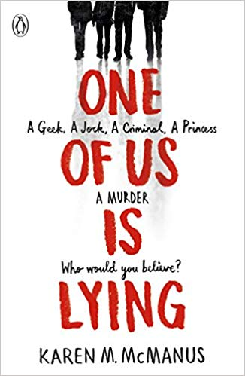
Summer Reading List for Incoming 9th Graders

Dear Bishop Ludden Parents and Students,
This year the English Department has decided to compile a list of books for each grade. Your student will be responsible for choosing one book from their grade level list and reading it over their summer break.
Along with this, they will be responsible for taking some short notes on each chapter. These chapter notes will be collected and taken for a grade on the first day school, September 4th 2019. The function of taking these notes is two-fold. First, it is to help students break down what they are reading for better comprehension and personal analysis. Secondly, it is to show their teachers that they thoroughly read the book. Each student will receive a Chapter Chart with this list and additional copies can be printed off of the Bishop Ludden website.
In regards to obtaining a book, you can either purchase the book your student selects at any bookstore that has it available, or go to a public library and check the book out. Students will not be required to have the book for school.
As an English Department, above all else, we want this summer reading to be enjoyable. Please help your student pick a book from their grade level list that will help them not only develop a love of reading, but also interest them on a personal level.
If you have any questions you, or your student, can contact their current English teacher or Mike Morgan.
Thank you, and happy reading.
The Bishop Ludden English Department

