The Fault In Our Stars  By John Green  The Fault In Our Stars is a fabulous book about a young teenage girl who has been diagnosed with lung cancer and attends a cancer support group. Hazel is 16 and is reluctant to go to the support group, but she soon realizes that it was a good idea. Hazel meets a young boy named Augustus Waters. | 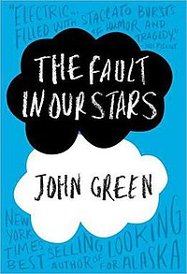
Flowers for Algernon  By Daniel Keyes  Charlie Gordon is a mentally disabled thirty-two-year-old man about to undergo a major elective surgery to improve his intelligence. We're basically reading his diary as he undergoes the whole process. ... He also buddies up to super-smart Algernon, a mouse who's already undergone the experimental surgery. | 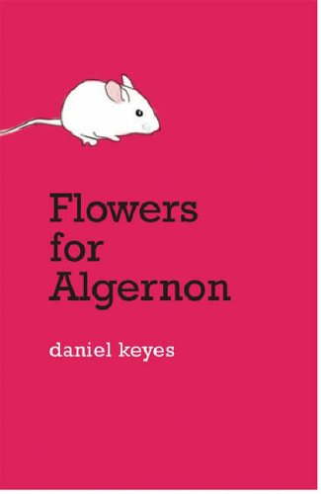
Skink No Surrender  By Carl Hiaasen  Richard Sloan is worried when his cousin and best friend, Malley, fails to meet him for their regular nightly exploration of Loggerhead Beach, scouting for turtle nests. Noticing a soda straw poking out of such a nest, Richard pulls it up and is surprised when a homeless man, "Skink", bursts out of the sand and complains about Richard ruining his trap. This only the beginning of their adventures. | 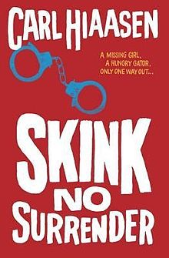
The Perks of Being a Wallflower  By Stephen Chbosky  Fifteen-year-old Charlie is coping with the suicide of his friend, Michael. To lessen the fear and anxiety of starting high school alone, Charlie starts writing letters to a stranger, someone he heard was nice but has never met in person. | 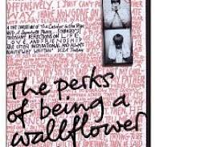
Water for Elephants  By Sara Gruen  Jacob Jankowski, a veterinary student, is close to graduating when a terrible tragedy forces him to leave school. With nowhere else to go, he hops on a passing train and finds it belongs to a traveling circus. Jacob takes a job as an animal caretaker and meets Marlena, a beautiful circus performer. Their shared compassion for a special elephant named Rosie leads to love, but August, Marlena's cruel husband, stands in their way. | 