Summer Reading List for Incoming 11th Graders

Little Fires Everywhere  By Celeste Ng  Mia and Pearl move to Shaker Heights, where lives are meticulously planned and everyone falls in line. The free spirited mother daughter duo challenge this status quo while endearing themselves to the local Richardson family. When town drama pits the two families against one another old secrets are uncovered while friendships and family relationships are put at risk. | 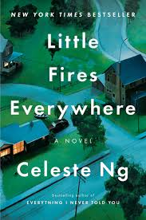
The Martian  By Andy Weir  Mark Watney is an American astronaut trapped on Mars in the year 2035. Left behind after being assumed dead he must use his knowledge of botany and superior problem solving skills to stay alive while NASA figures out how to bring him back home. | 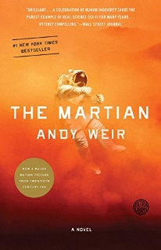
Black Enough  Edited by Ibi Zoboi  A collection of short stories that explore the issues associated with being a black teen in the United States today. Topics include family dynamics, mental health struggles, falling in love, finding yourself, and more. | 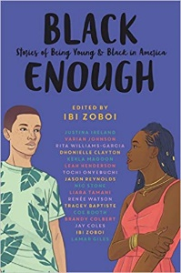
The Queen of the Tearling  By Erika Johansen  Princess Kelsea Raleigh Glynn is on a mission to overthrow the Red Queen and take back the throne that once belonged to her late mother. With the help of brave knights and a magical gemstone, Princess Kelsea fights to overcome her insecurities and discover within herself greater bravery than she’d ever imagined. | 