York  By Laura Ruby  A centuries old mystery, a determined real estate developer, and a ticking clock. This is what Tess, Theo, and Jaime are up against as they race through an alternate version of  New York City to save their homes from destruction. | 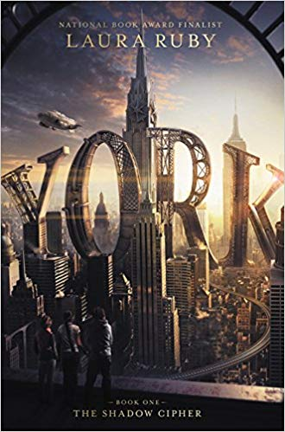
The Other F-Word  By Natasha Friend  This book is all about your average American family: four moms, four half-siblings, and one unidentified sperm donor. When medical questions cause Milo to search for the donor connections are made, feelings are hurt, and the word “family” is defined. | 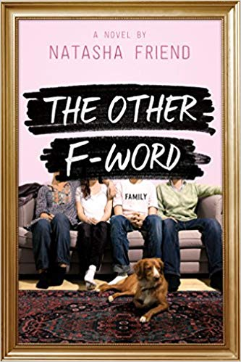
Americanized: Rebel Without a Green Card  By Sara Saedi  Sara is a teenager. She worries about problems with her friends, grades in school, and how to relate to her family. She just added one more worry to her list, though, because she just learned that her family is in the United States illegally. The story follows Sara as she struggles to cope with this new information and what it means for her future. | 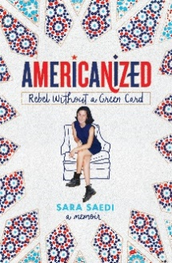
One Of Us Is Lying  By Karen McManus  Five students walk into a high school detention. Only four walk out. When Simon’s death is deemed a homicide the other four become suspects. Each of them has a story to tell, defending themselves. Can you spot the liar? | 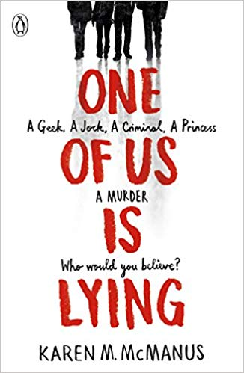
Summer Reading List for Incoming 9th-Graders

